**Game 2 Lab Manual: K-space magiK**

**Why?**

MRI gets its data from the so-called “k-space”, which is a special representation of the image we acquire. Just like sheet music breaks down the musical signal (the audio waveform) to its frequency components (notes), k-space shows us what spatial frequency “notes” or harmonics exist in the image. Because there is a one-to-one relationship between the image and k-space, we can travel freely between the two without losing information. Changing and deleting parts of k-space will have interesting effects on the image, which are very relevant for MRI because we don’t get a perfect k-space all the time as random noise and other factors start corrupting it. In this game, we will tweak our data in many ways and explore the magical relationship between the two domains!

**Materials**

* Water phantom
* Star phantom
* Letter phantoms
* Brain sample tube

**Background**

1. Key terms

* Signal
* Sampling
* Spectrum
* Fourier transform
* Image space
* K-space

1. Basics

An image can be seen in more than one way. Just like a piano sonata can be represented either as a WAV file (a time domain signal) or discrete notes on a sheet music, an image can be in the form for human eyes as a grayscale map or as its spatial frequency domain, or k-space. Any 2D image (MR image, photo, drawing) can be converted to a k-space, and any 1D signal can be converted to a spectrum. The conversion process is essentially the same.

1. Explanations

Signal: a signal is a function representing some processes we are eager to investigate. It can be discrete or continuous, categorical or interval, and in 1D or 2D or 3D or more dimensions. Examples: ECGs, brain waves, average June temperature of the past 10 years in your city… In this game, “signal’ is used specifically for a 1-dimensional continuous wave/curve in time. For example:

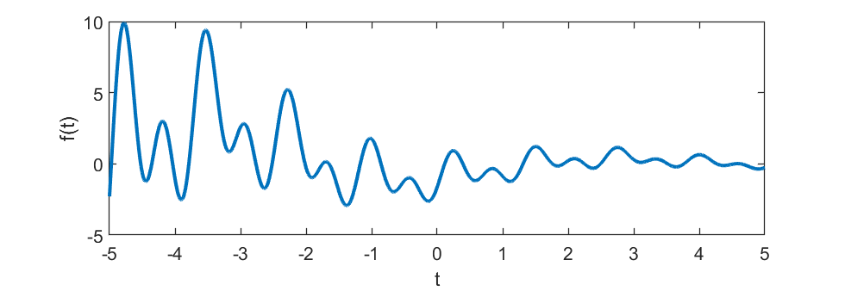

Sampling: This refers to the process of gathering data at selected locations in k-space or in time. In discrete sampling, we get an approximate idea of a continuous signal by looking at it at a limited number of times. Below, the signal above is sampled at two different rates and the resulting discrete signals look quite different. We want to sample just enough to get a fair representation of our signal.

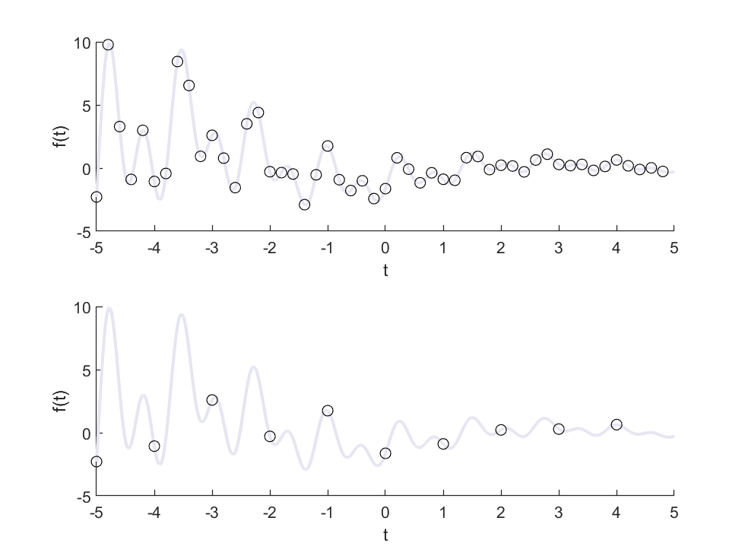

Spectrum: this is a curve that shows you how much of each frequency is in a signal. For example, the following signal is a sum of 3 different sinusoidal waves:

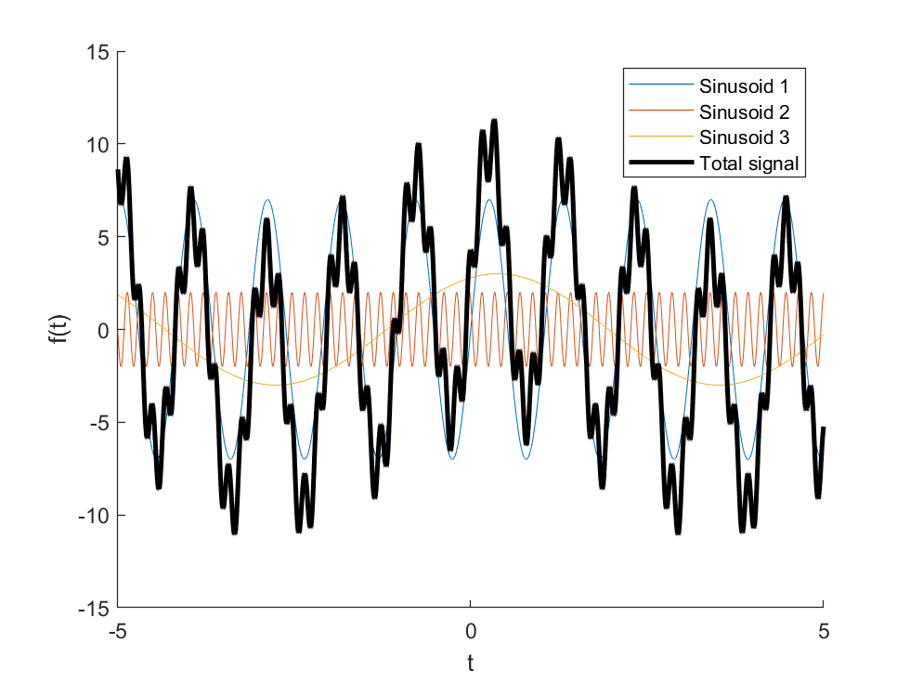

Its spectrum is shown below. As you can see, the three waves are represented as three pairs of peaks on the spectrum, each corresponding to a distinct frequency as marked by the horizontal axis.

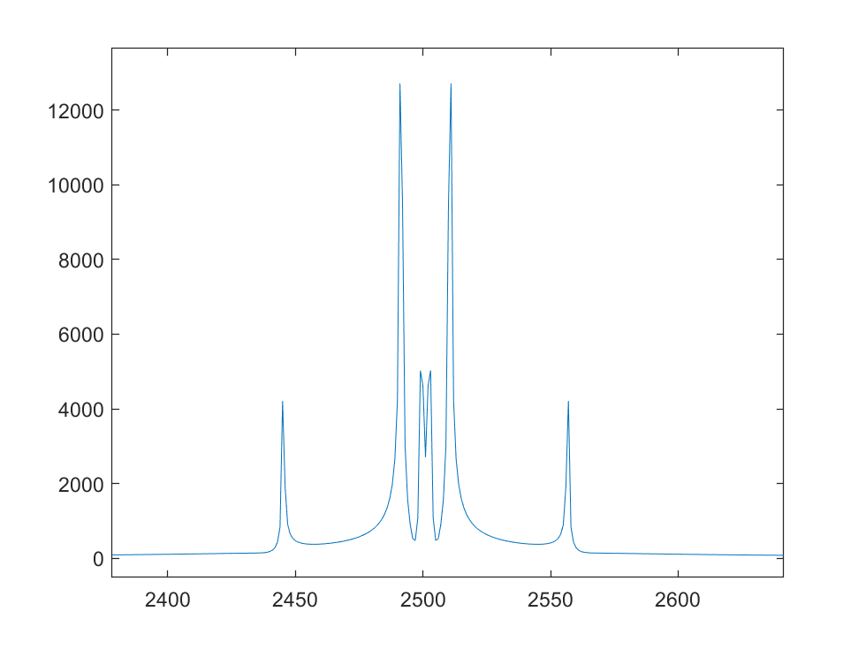

Each pair of peaks on the spectrum corresponds to a sinusoidal wave on the signal. Higher peaks means the component has larger amplitude, and peaks closer to the center means the component has lower frequency.

Fourier transform (FT) is a mathematical operation that converts a **signal** to its **spectrum**. This process is one-to-one: we can apply the inverse Fourier transform to the spectrum and get back the same signal. The amount of information is preserved before and after the transformation. The equation for a FT and an inverse FT (IFT) is shown below. It really is just an integral with complex exponentials thrown in!

Forward FT:

$X(f)=\int_{-∞}^{+∞}{}x(t)e^{-i2πft}dt$

Backward IFT:

$x(t)=\int_{-∞}^{+∞}{}X(f)e^{+i2πtf}df$

Some interesting properties of the FT are summarized below:

1. The FT of the sum of two (or more) signals is equal to the sum of the FTs of those two (or more) signals.
2. The FT of the product of two signals is equal to their FTs convolved together (<https://en.wikipedia.org/wiki/Convolution>), and vice versa.
3. If you multiply a signal by a constant C, the FT of it is also multiplied by C.
4. If a signal gets wider, its FT gets narrower, and vice versa.
5. If you move the signal horizontally (to the left or right), its FT gets a linearly varying complex phase. If you move the FT, the signal gets the same.

You will get to explore some of these properties on the game interface!

Image space is the space explored in Game 1: grayscale maps represented as matrices. Each entry of the matrix represents a point in space and its magnitude tells you how bright the image is at that spot.

K-space is what you get if you perform a Fourier transform on the image space.

Because the image space is 2D, we have to integrate in two directions.

$G(k_{x},k_{y}) = \int_{-∞}^{+∞}{}\int_{-∞}^{+∞}{}g(x,y)e^{-i2π(k_{x }x+k_{y}y)}dxdy$

The same properties apply to the 2D FT as described above for the 1D FT.

Spatial frequency: if a sine wave is represented by a pair of peaks on the spectrum, what is represented by a pair of peaks in k-space? This is where spatial frequency comes in. See the first figure below:



K-space image

In k-space, there are two peaks symmetric by the origin (look very closely, or zoom in if needed). The line connecting the peaks is horizontal. In the image, we see stripes. The brightness is not either black or white, but varies along the same horizontal line in the form of a sinusoidal function. Compare this to the next figure:



K-space image

Here, the peaks are further apart but still oriented along the horizontal line. The stripes are narrower indicating a **higher spatial frequency**. Hence, each spatial frequency corresponds to a 2D sinusoid wave of a certain width. The higher the frequency, the closer the peak gets to the edge of k-space, and the narrower the stripes get because they vary faster in a given amount of distance. Now, observe the last figure below:



K-space image

The peaks, while still symmetric about the origin, have been rotated by 45 degrees. The 2D wave was also rotated and the direction perpendicular to the stripes still corresponds to the line connecting the peaks. Therefore, the 2D spatial waves have both a frequency and a direction defined by an angle between 0 and 180 degrees.

Importantly, the points in k-space and image-space do NOT map one-to-one. Changing one point in k-space will change ALL POINTS in the image space, and vice versa. This is because each point in k-space corresponds to a spatial wave that occupies the entire image. Because of this, many image artifacts in MR are not straightforward, but require some amount of “k-space intuition” to understand. You will further develop this intuition with the Game’s GUI.

k-space and MRI acquisition: while the camera and the human eye both speak the language of image space (as projected onto the image sensor in the camera and the retina in the human eye), MRI speaks in k-space - it is the natural place where we get our data. This is because of the following:

1. The protons in hydrogen atoms are tiny magnets that, when placed in a magnetic field, rotates around that field’s direction.
2. The stronger this field is, the faster they rotate.
3. A rotating thing can be represented as a complex exponential. For example, the position of a dot traveling on a unit circle counterclockwise at constant speed can be represented as:

$x(t) =cos(ωt), y(t) = sin(ωt)$

Or:

$x(t) = Re\{ r(t) \}, y(t) = Im\{ r(t) \}$

Where

$r(t) = e^{iωt}=cos(ωt)+i sin(ωt)$

Is a complex function representing the position function.

1. When we apply an imaging gradient field (one of the three key magnetic fields that the MRI scanner uses), the complex exponentials get their frequencies modulated in such a way that the signal **is** the Fourier transform of the image. The signal in general is a spatial integral of all the tiny rotating magnets, so this process **physically** performs a Fourier transform (with the protons themselves being the complex exponential terms) !
2. If we apply the gradients correctly, each point in time gets mapped to a different point in k-space, and we know this mapping.
3. By sampling the signal at different times, we can fill up k-space.
4. Lastly, we perform an inverse 2D FT to convert the k-space back to the image. This step is called image reconstruction.

**Lab procedures**

1. Explore 1D transforms
   1. Select the “sine wave” signal type on image/signal presets and press “Get signal”. Describe the signal in your words:
   2. Press “Forward” to perform a Fourier transform. The right chart now displays a spectrum of the signal. Describe the spectrum.

* 1. Try changing each of the parameters, generate the signal, and get its spectrum each time. Describe what each parameter does to the signal and to the spectrum:

|  | Signal | Spectrum |
| --- | --- | --- |
| Vertical Scale |  |  |
| Horizontal Scale |  |  |
| Shift |  |  |
| Phase modulation |  |  |

* 1. Experiment with other options in the “select signal” dropdown.
  2. Experiment with options in the “select spectrum” drop down on the right. Use the “backward” button to perform an inverse Fourier transform, which recovers the signal from its spectrum. What happens when you press Forward and then Backward or vice versa?

* 1. In the middle, go to the “Draw” tab and draw any curve you like. Press “Use” and then “Get signal” or “Get spectrum” to load it onto the panel you want. Perform transformation of your signal and spectrum. Use the drawing board and the preset signals to explore at least one of Properties 1-5 of the Fourier transform. Record your findings below with sketches of the signals and spectra you used.

| Property # | Signal | Spectrum | Findings |
| --- | --- | --- | --- |
|  |  |  |  |
|  |  |  |  |
|  |  |  |  |
|  |  |  |  |

1. Explore 2D transforms
   1. Now we can look at the 2D analog of the same process. Go to the “2D Image” tab and choose any image you like. Press “Get Image” and then “Forward” to look at the k-space. Repeat it for a few images.

What do the k-spaces have in common?

* 1. Get the image of a 2D sine wave and generate its k-space. What do you see? You might have to zoom in to see the details of this one. How does this compare to the 1D sine wave?
  2. Try changing each of the parameters below, generate a new image, and get its k-space each time. Describe what each parameter does to the image and to the k-space:

|  | Image | K-space |
| --- | --- | --- |
| Rotation |  |  |
| Horizontal Scale |  |  |
| Shift |  |  |
| Phase modulation |  |  |

* 1. Perform the same steps in c, but using the Backward transform on the “Double spike” 2D k-space preset (press “Get K-space” to generate the k-space first).

|  | K-space | Image |
| --- | --- | --- |
| Rotation |  |  |
| Spike separation |  |  |

* 1. Explore other images and k-space options and perform multiple backward and forward transforms.
  2. In the middle, go to the “Draw” tab and draw any image you like. Press “Use” and then “Get image” or “Get k-space” to load it onto the panel you want. Perform transformation of your signal and spectrum. Use the drawing board and the preset signals to explore at least one of Properties 1-5 of the Fourier transform in 2D. Record your findings below, with sketches of the images and k-spaces for each experiment.

| Property # | Image | K-space | Findings |
| --- | --- | --- | --- |
|  |  |  |  |
|  |  |  |  |
|  |  |  |  |
|  |  |  |  |

1. Perform k-space magik!
   1. Load one of the MRI images and generate its k-space.
   2. Go to the “Sampling” tab in the middle. The square represents k-space and the four lines slice it up. The lighter part will be preserved and the darker part will be erased from our k-space. Press “APPLY” to see the slicer applied.
   3. Move the four lines closer to the middle of k-space so only a small portion of light gray remains, and press apply. Transform the restricted k-space back to image space. How did the image change? Why? Can you relate this to the sine wave experiments above? State your conclusion:

* 1. Re-load the image and generate a fresh, complete k-space; then, press “Invert” in the slicer and “Apply” to block out the center but preserve the periphery of k-space. Transform backwards. What do you see now? Describe your findings:
  2. Explore the slicer to section out different parts of k-space and see its effects. Moreover, you can also use the “Erase” tab to block out more interesting shapes and see what it does to k-space! Describe your findings in the table:

| K-space blockout (describe or sketch) | Effects on the image |
| --- | --- |
|  |  |
|  |  |
|  |  |
|  |  |

1. Free exploration suggestions (optional)

Note: On the “upload” panel, you can upload an image and generate its k-space. Use “Erase” or “Slicer” to apply different filter effects onto your image and then transform backwards. “Recover” reloads the complete image. You can use the toolbar on top to save a local copy of the resulting image.

* 1. Explore the effects of undersampling factors on the “sampling” panel.
  2. Using the properties of k-space, plan out and create your own art by drawing an image, converting it to k-space, manipulating it with “erase” and “sampling”, and exporting it.
  3. Using a photo you have taken and knowledge of k-space, style it in three different ways by changing its k-space and export them.
  4. Compose a haiku or a short free-form poem about k-space using what you learned today.

**Questions**

Q1. Which statement below is incorrect about the Fourier Transform?

1. It is an irreversible process because you cannot figure out the original signal from the transformed signal.
2. Mathematically, it can be performed as an integral with complex exponentials over time or space.
3. The FT of the product of two signals is not necessarily the product of its FTs.
4. The output of the inverse Fourier transform can be entirely real (i.e. without imaginary components)

Q2. What does k stand for in the term “k-space”?

1. Key imaging variable
2. Kinetic energy conversion
3. Spatial frequency
4. Coordinates of reconstruction

Q3. What statement about k-space is correct?

1. The middle of k-space represents the edge information and small details on the image
2. The periphery of k-space represents the overall signal level of the image
3. K-space is artificially created from the acquired image so we can manipulate the image contrast
4. K-space is directly sampled and the image is created afterwards in an extra step

Q3. What happens if I slice the k-space in the following way:

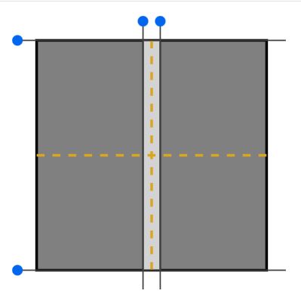

A. Vertical edges will get blurry

B. Horizontal edges will get blurry

C. Only vertical edges will be visible

D. Only horizontal edges will be visible

Q4. What is incorrect about spatial frequency?

1. Low spatial frequencies corresponds to information in the center of image space
2. Each point in k-space tells you the amplitude of one spatial frequency
3. High spatial frequencies corresponds to thinner stripes
4. In 2D, spatial frequency has a direction along which the wave amplitude changes